The Ultimate guide to Honeycomb LanternLITE™ roof blinds
Orangeries, Atriums and conservatories are a fantastic way to open up your home bringing light and openness into your home. These glass roofs bring natural light and free solar energy into the home. However, in order to receive the maximum benefit from your roof window you will need to find a way to control your environment.

Without a ROOF LANTERN blind you are very likely to experience the following:-

 | Heat Gain in the Summer | TRANSMITTANCE: The suns rays pass through the glazing, hit objects in the room eg walls, furniture which absorb the radiation and radiate it back into the room: otherwise known as the GREENHOUSE EFFECT.
 | Heat Loss in the Winter | Even with the heating on you may find your orangery is cold during the WINTER and first thing in the morning and last thing at night.  Heat is lost through:-  CONDUCTION (Loss of heat through the glass of the window)  CONVECTION (THE DRAFT LOOP: Loss of heat through warm room air reaching the glass, cooling then cool air falling back into the room for you to have to re-heat)  AIR LEAKAGE (Heat lost through cracks in the frame or from ill fitting glass)
 | GLARE | Harsh sunlight which prevents you watching tv and strains the eyes.

The only way to control the above is to invest in either an external window covering, or an internal horizontal blind such as the LanternLITE™ Honeycomb roof blind.

So why LanternLITE™ blinds?

We are so proud to be the innovative company who have developed and manufacture the LanternLITE™ roof blind system. Roof lantern blinds are not a new concept by any means. You can go to a handful of specialist and expensive companies who will come round to your house and measure and fit for you similar products. But we have recognised that this solution is not for everyone and some people like to be in control of their installation and their budget! DIY LanternLITE™ blinds offer you a hard-working, robust product which looks professional whilst saving you thousands of pounds by cutting out the middle man and ordering directly from the factory.

The LanternLITE™ Honeycomb blind

The LanternLITE™ Honeycomb roof blind is a cellular blind housed within its own frame. This frame then sits on L shaped angle brackets which are fixed within your roof lanterns reveal to create a sleek shelving system. The Honeycomb LanternLITE™ is available in both Antiglare and Blackout fabric and also in a choice or manual, hard wired electric or battery solar powered electric so it is a very versatile blind.

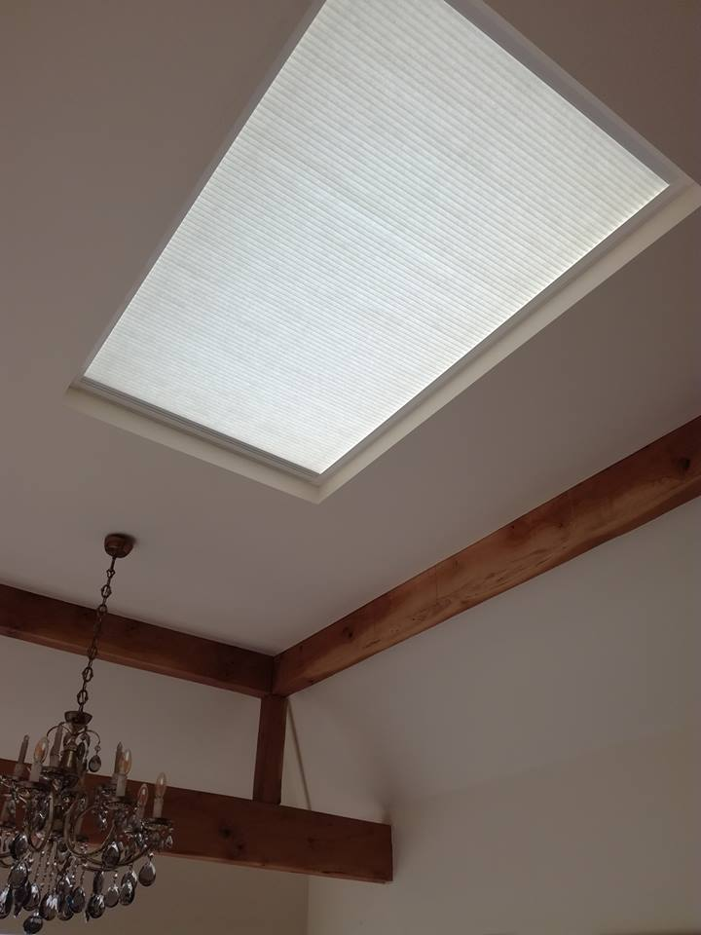  Available in Antiglare fabric (ideal or orangeries, living rooms and kitchens) | 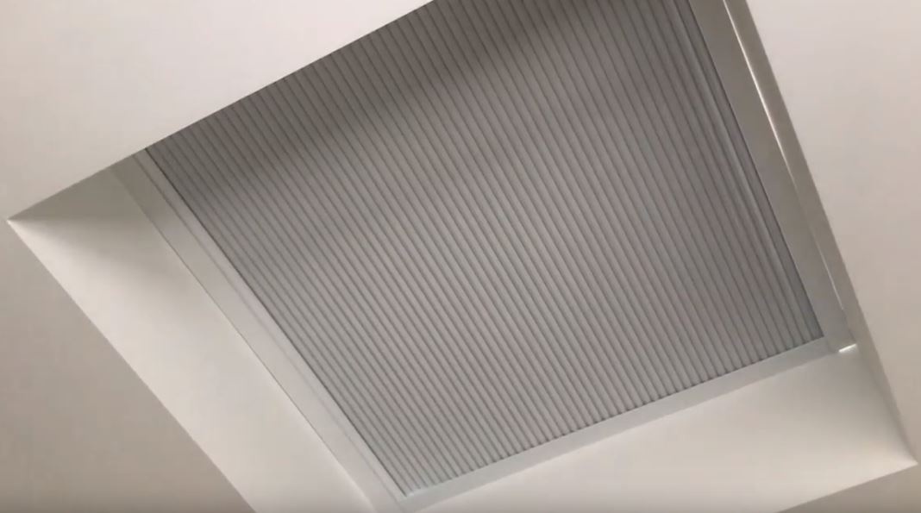  Available in blackout fabric (ideal for bedrooms, tv rooms and cinema rooms).

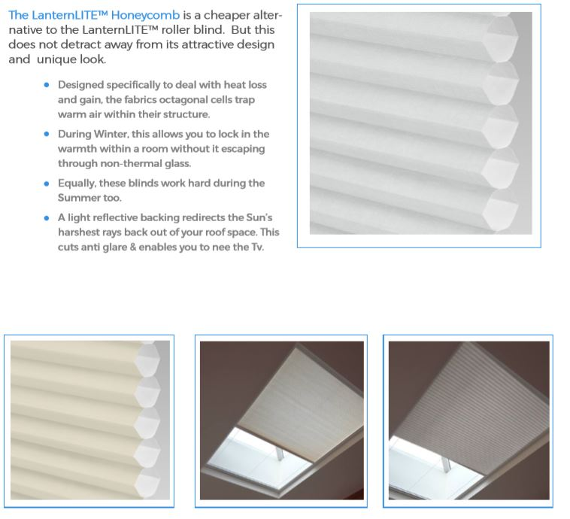

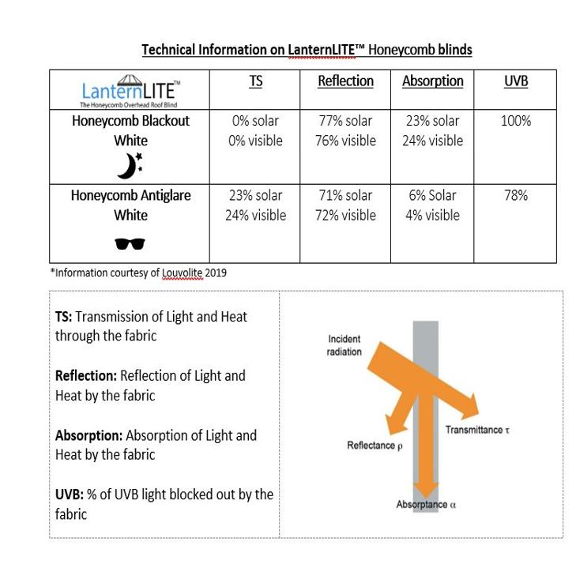

Dimensions of the blind

LanternLITE™ Honeycomb  Antiglare THERMAL fabric | LanternLITE™ Honeycomb  BLACKOUT THERMAL FABRIC (FOIL LINED)
 | 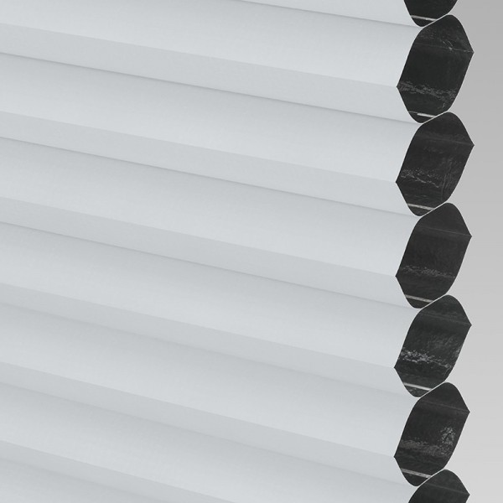
Size of stack  1cm stack of fabric = 60cm length when extended.  Therefore if you have a window that is 300cm long  300 /60 = 5cm. Don’t forget you need to add on the depth of the frame which is 3.5cm then take into account any fixings eg the angle shelf. So if you add on 4cm that should be enough. | Size of stack  1cm stack of fabric = 50cm length when extended.  Therefore if you have a window that is 300cm long  300 /50 = 6cm. Don’t forget you need to add on the depth of the frame which is 3.5cm then take into account any fixings eg the angle shelf. So if you add on 4cm that should be enough.
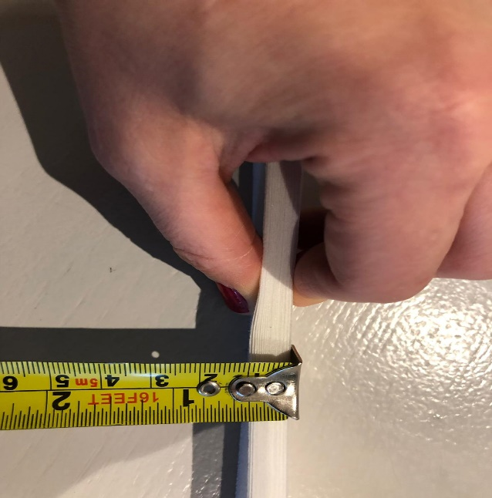 | 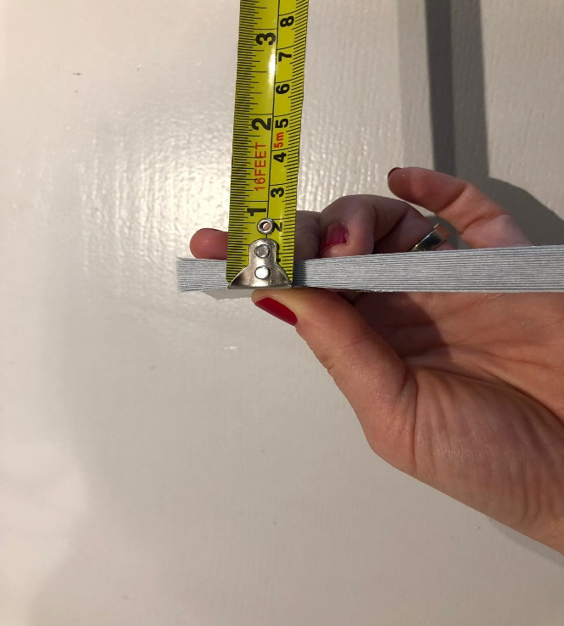
Size of shelf  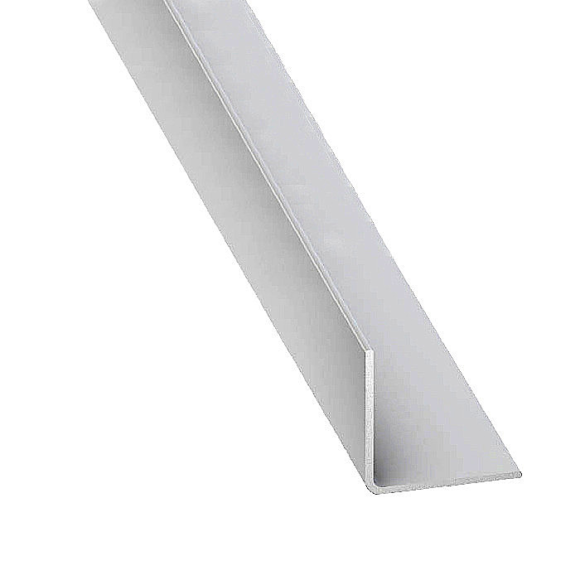  Cross section of 25mm angle which creates shelf around the recess for the blind to sit on. | Size of blind on shelf  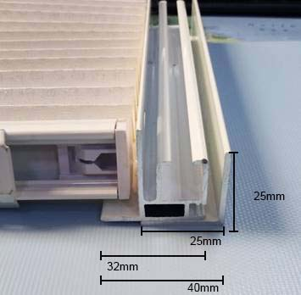  Blind in its own 32mm frame sat on the 25mm fixing angle.

Guidewires
Our Honeycomb LanternLITE™ blinds are supported by very fine steel guidewires. These wires guarantee that your blinds will not sag and will work fantastically for many years to come. There are questions surrounding these wires though. There are always 2 x wires situated 50mm in from each side of the blind. These wires are the wires that pull the blind backwards and forwards. Then depending on the width of the blind there are always support wires distributed through the body of the blind. These wires are not visible when the blind is closed (ie is across the window), but they are visible when the blind is open. There is always one wire every 450mm. Here is the equation we use to calculate the number of wires.

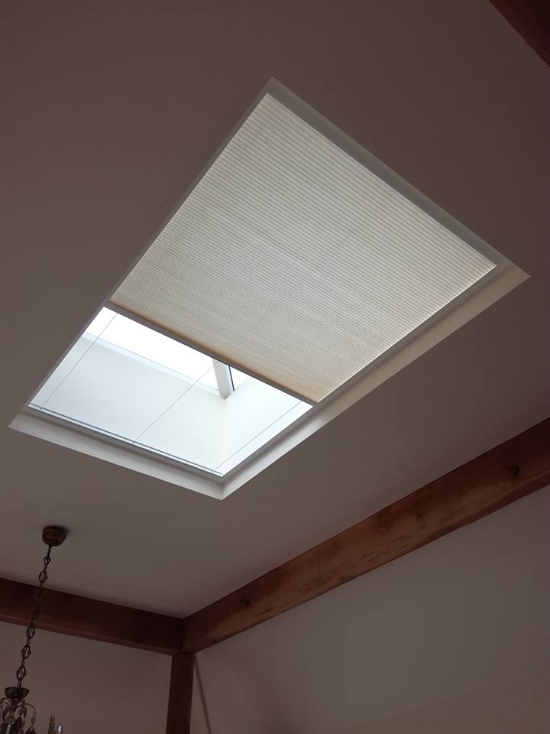

Width - 100mm = xxxxmm / 450 = x.xx + 2.
There will always be 2 filos (support wires) 1 filo 50mm in from each side hence why we take 100mm off.
Eg. 1934mm - 100mm = 1834 / 450 = 4.07 (if this is .5 or greater then round up eg 4.5 =5) + 2 = 6 so this blind should have 6 filos.

